From: https://davidstockmanscontracorner.com/the-harlot-of-wall-street-why-the-feds-war-on-main-street-must-stop-part-1/

The Harlot Of Wall Street: Why The Fed's War On Main Street Must Stop, Part 1
By David Stockman. Posted On Monday, November 4th, 2019
The Federal Reserve pretends to have eyes only for main street and the fulfillment of its statutory mandate with respect to maximum employment, stable prices and moderate interest rates. In fact, its only client is Wall Street and it does tricks of the monetary variety---wittingly or otherwise---exclusively for its financial pleasure.
Unfortunately, the Fed's monetary harlotry comes at immense cost to main street America. It
- crushes savers and retirees;
- causes the C-suites of corporate America to strip-mine their cash flows and balance sheets in order to fund stock buybacks, M&A deals and other Wall Street pleasing financial engineering gambits; and
- results in a virulent inflation of financial assets that confers unspeakable windfalls to the tippy top of the wealth ladder.
At the same time, its Humphrey-Hawkins mandates and macro-economic management functions are actually a glorified beard. It ostentatiously pursues them, but assiduously refuses to acknowledge that they don't work, can't be fixed and cause more harm than good.
That's in part because the monetary policy transmission channels to main street consumers and businesses were busted long ago, owing to the massive amounts of private debt and financial speculation its own efforts have fostered over the last several decades.
Consequently, the vast majority of households are now at Peak Debt and can't leverage up further in response to the Fed's allegedly "stimulative" ultra-low interest rates. Likewise, the C-suites have become stock trading joints which use cheap debt and cash to goose the value of their stock options on Wall Street, not invest in productive plant, equipment, technology, human capital and other ingredients of true growth on main street.
Beyond that, the Fed's single, crude policy tool of controlling the price of credit---directly through pegging the money market rate and indirectly through QE repression of bond yields---is virtually impotent in today's macroeconomic context.
That's because what we call "central banking in one country" is massively swamped by the multi-trillion trade, finance and capital flows of the planet's $85 trillion [per year], deeply integrated economy and financial infrastructure. For example, these forces drive inflation on a global basis without regard to the Fed's fetishistic 2.00% target---even as it is dubiously measured by one arbitrary metric of domestic inflation (the PCE deflator).
Likewise, domestic output, resource utilization and labor markets are not locked up in some self-contained economic bathtub. That is, a closed system into which the Fed can inject just the right amount of "demand" so as to fill potential GDP to the brim of full employment per its Humphrey-Hawkins mandate.
But the idea of a closed-system of Potential GDP and Full-Employment is an obsolete relic in today's world. The domestic supply-side is heavily pushed, pulled, textured and catalyzed by the infiltrations and competitive impacts of the global economy's teeming supply of labor, capital, technology and enterprise. Contesting with these elemental forces---like the Fed's recent attempts to off-set the Trade War instigated global slowdown---is simply way above its pay grade.
Accordingly, the Fed's obsession with domestic labor market conditions and the second decimal place rate of inflation essentially amounts to impact-free arm-waving. It relentlessly calls out these variable in its internal deliberations and external communications, but it's all just so much hot air.
Stated differently, the Fed's broad, macro-economic management functions can't possibly be executed effectively in today's deeply integrated global economy. Pursuit of these objectives only generates collateral effects--excessive household debt burdens and rampant corporate financial engineering---which actually worsen the performance of the main street economy.
So its statutory mandates should be repealed and it should stop macroeconomic meddling entirely.
Likewise, in this day and age the main street economy arguably does not need a central bank to manage narrowly construed money functions, either. Indeed, when these purely money functions are examined in their own right, the extent of the Fed's
- massive usurpation of financial power and
- mission creep
becomes startlingly clear.
In the first place, the Fed doesn't really possess an irreplaceable monetary elixir---so-called higher powered money---without which credit expansion and the economic growth would not take place. To the contrary, at market clearing interest rates and asset prices on the free market there would always be enough credit and long-term capital from private savings to meet the needs of a growing and prosperous capitalist economy.
It is worth noting in this context that the designers and legislative architects of the Fed back in 1913-- led by the great financial statesman, Congressman Carter Glass---had no notion at all that the new Reserve Banks were needed to supply high-powered money to the banking system in order to facilitate credit growth and the expansion of commerce in the ordinary course.
After all, Congressman Carter Class, his legislative collaborators and their banking advisors had no reason to deny their lying eyes: Since the Civil War they had witnessed decades of massive economic growth, unprecedented industrial expansion, stunning technological progress and soaring living standards, yet there had been no central bank at all!
So they knew these gifts come from capitalism on the free market, not the machinations of the state, including a new fangled central banking branch. And they had no reason to be confused about that truth because there was no "but for us" Wall Street/central banker lobby propagating self-serving economic canards of the type which obfuscate understandings today.
Indeed, they knew that private savings is the source of credit and capital in the financial system and on the strength of the 40-year boom it had enabled, they saw no need to fix something which wasn't broke.
Instead, what they thought was broken was the liquidity function, not the mechanisms of ordinary course credit expansion. So their primary focus was on extraordinary times--financial panics and crises---when a "lender of last resort" could supply liquidity to the banking system, thereby obviating the need for unnecessary loan liquidations and credit stringencies with respect to solvent borrowers, as the latter term was understood by the starch standards of the day.
Moreover, these "extraordinary" circumstances and lender of last resort notions ,which undergirded the original Fed remit, were largely anchored in constraints of monetary time and space. But the banking and financial arrangements of 1913 have long since been transcended by modern communications technology and the global internet.
That is, cash and bullion were not readily and speedily transportable and the local inter-bank clearinghouses which performed clearance and settlement functions among member banks and frequently provided back-up liquidity lines----even local scrip in extremis---were not interconnected by mechanisms which could smoothly and rapidly move money from surplus to deficit regions and markets.
In fact, most of the so-called panics between 1870 and 1913 were either driven by agricultural seasonality and the resulting ebb and flow of money between the countryside and the cities or by the inherent pre-internet sluggishness of the mechanisms for moving money---including cash, bullion and ledger credits---from surplus to deficit banking markets.
A core feature of this system weakness was the classic retail bank run. When depositors came to distrust the solvency or liquidity of their local bank, they had no option but to line up at the counter and, when their turn came, carry off greenbacks, gold coins or even bullion if they were depositors of means.
Today, of course, there are no retail bank runs and not just owing to deposit insurance. With the click of a mouse, depositors can move their funds to another institution, thereby causing silent runs that well managed banks can stay ahead by accessing alternative funding markets which are instantly and globally available to solvent institutions at a price.
To be sure, you can't get blood out of a turnip or safely liquefy a bank which is insolvent. But even the Fed's founders didn't see the 12 regional Reserve Banks they created in that light. The new central bankers Carter Glass enabled were green-eyeshades, not PhD macroeconomists; they weren't about to make discount loans against anything but prime collateral defined as trade bills drawn against goods already produced or sold.
So even the lender of last resort function as it was properly understood in 1913 has become largely vestigial. Risk managers equipped with computerized analytics can assess the solvency of a liquidity-seeking bank in East Jesus Iowa or anywhere else in a banking minute.
In most instances, solvent banks today would not need a Fed discount window or repo desk to access back-up liquidity. They would just have to pay the going price for emergency funds on an instantly accessible inter-bank market.
Of course, Fed apologists would claim that what might be true for an individual bank in liquidity duress is not true for the system as a whole in the face of a systemic contagion like that which purportedly erupted in September 2008. We treat that canard at length in a subsequent installment, but suffice it to say here that in today's technologically enabled financial system it is virtually impossible to have a system-wide liquidity run.
That is, unless you have price controls on credit, which is exactly why we had the Bernanke Panic of 2008.
Exactly at the point in the summer of 2007 when the financial system had become rife with excess leverage and demand for speculative funds in the mortgage-backed securitization sector and elsewhere and when the first cracks in the mortgage mania became apparent with the failure of the Bear Stearns mortgage funds and the sudden distress of Countrywide Financial Corporation in August----the Bernanke Fed did exactly the wrong thing.
The financial system desperately needed a sharp rise in interest rates in order to
- choke-off speculative demand for funds and to
- force the liquidation of bad credits before the entire system metastasized uncontrollably.
That is, by 2007 the mortgage bankers were desperately conspiring to hide the extent of bad subprime credits by offering refi loans at teaser rates before existing mortgages went completely sour. But in a market that is working effectively under these conditions, rising interest rates would have caused these bad loans to be called or liquidated because underwater borrowers would not qualify for a "refi" stick save.
Needless to say, the Keynesian economic doctors who dominated the Bernanke Fed were having none of the purging process required by honest finance on the free market. So they hurriedly and relentlessly pushed down money market rates, thereby inadvertently fueling demand for funds to keep zombie borrowers alive in the residential mortgage sector and elsewhere.
In fact, the catalyst for the September 2008 Wall Street meltdown lies right here in the path of the Fed's pegged funds rate after August 2007. At the time, the rate was 5.25% and absent Fed intervention to arbitrarily lower the price of credit, money market rates would have risen sharply over the next months and quarters, thereby bringing the mortgage and credit mania to an early halt.
But Bernanke lowered the money market rate to
- 4.0% by January 2008,
- 2.o% by August when the Fannie Mae/Freddie Mac crisis flared and then to
- a historically unprecedented and ridiculous level of 0.15% by December.
There is surely nothing more wrong-headed in the annals of central banking that this panicked pouring of monetary kerosene onto the speculative fires the Fed had already ignited---even if Bernanke later churlishly commended himself for having the "Courage to Print".
In any event, the so-called systemic "contagion" and liquidity crisis of 2008 was manufactured in the Eccles Building owing to the Fed's misuse of its essential policy tool---the pegging of money market rates based on the fuzzy-minded macroeconomic views of 12 members of the FOMC.
A freely functioning interest rate would have curtailed the mortgage and credit bubbles long before they metastasized to the lunatic levels eventually reached; and would have also put the lie to the claim that activist central banking is needed to ameliorate systemic contagions and liquidity shortages.
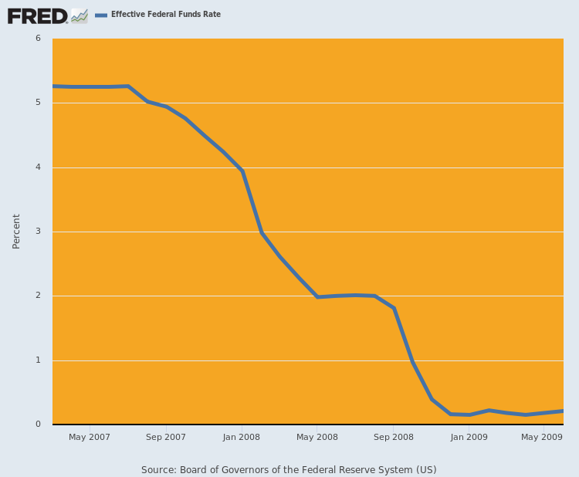
When you recognize that system-wide liquidity shortages and contagions are the result of Fed price controls on credit and that today's technologies would permit stronger banks to be timely lenders of last resort to weaker but solvent banks faced with liquidity pressures, it opens the door to an even broader consideration as we will address in Part 2.

